Motion and Force in a Gravitational Field

Test 1: Energy, Vectors and Projectiles

Name: __________________________________________ (30 OR 35 marks total)
Time for test: One Hour
Outcomes covered in this assessment task.
- describe and apply the principle of conservation of energy
- resolve, add and subtract vectors in one plane
- draw free body diagrams, showing the forces acting on objects, from descriptions of real life situations involving forces acting in one plane
  - describe and apply the concepts of distance and displacement, speed and velocity, acceleration, energy and momentum in the context of motion in a plane, including the trajectories of projectiles in the absence of air resistance—this will include applying the relationships: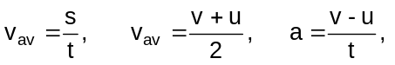
  - describe qualitatively the effects of air resistance on projectile motion
Unless told otherwise, assume no resistance.
- You throw a 0.100 kg ball up into the air and it reaches a height of 3.25 m above its release point. It then returns to the ground which is 0.750 m below where it was released. Calculate the kinetic energy lost as it hits the ground. (2 marks)

- You are doing a movie stunt. You have to leap from one roof to another 2.50 m away. There is a drop of 50.0 m if you fail (splat!!). You take a long run up and upon a signal from the director you leap over the gap. Halfway across you happen to glance down. Draw a free body diagram showing all the forces acting on you at that moment. (By the way, you do land safely on the other side.) (2 marks)

- Simon was driving home one day when second gear, with loud screeching, decided to stop working. To cut a long story short, the tow truck finally arrived and carted the car to the mechanics. The tow truck had a flat tray which travelled out backwards from the frame of the tow truck and tilted until it was under the front wheels of the car at an angle of 30.0⁰ to the horizontal. A tow rope was then attached to the car and a winch pulled the 955 kg car up the tray at a constant velocity. Calculate the tension in the rope as it pulled the car up the tray.
(2 marks)
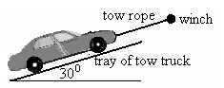

- At a local hockey game, Aimee hits a ball travelling at 14.0 ms⁻¹ north across to Chelsea, the ball is now travelling at 11.0 ms⁻¹ south. If the change in velocity took place in 0.400 s, what was the ball’s acceleration? (Don’t forget direction!) (3 marks)

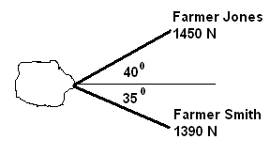

- In order to pull a large rock out of the way, Farmer Jones has asked for help. The rock is supplying a retarding force of 2.16 x 10³ N. The diagram shows the situation and supplied forces. Will they be able to pull the rock out? You must show calculations to justify your answer. (3 marks)

- Ben is on holiday in New Zealand and has been taken on a helicopter joy ride. The helicopter is travelling vertically upwards with a velocity of 17.8 ms⁻¹. Being a keen physics student, he has taken a small stone with him and when the pilot tells Ben they are exactly 254 m above the ground, Ben drops the stone. Determine the velocity with which the stone will hit the ground and the total time it is in the air from the moment Ben lets it go. (4 marks)

- Young Johnny and his brother Sam are playing a new game. Johnny rolls a large ball bearing along the top of a table with a constant velocity of 2.54 ms⁻¹ while his brother pushes a small trolley along the ground below. The idea of the game is to get the ball bearing to land in the trolley after leaving the table. This occurs when the trolley and ball are in the position shown and the trolley is released 0.83 m away from where it will catch the ball bearing. Calculate the height of the table. (4 marks)
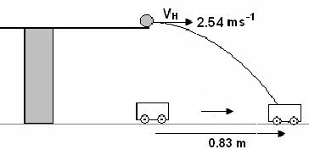

- The following shows a beach ball thrown a long distance from one person to another without air resistance.
  - If there were air resistance, and the two people didn’t move, would the second still catch the beach ball? _______________ (1 mark)
  - Draw the possible path of the beach ball with air resistance to justify your answer. (1 mark)
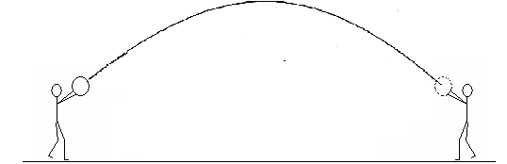

- You are a stunt co-ordinator using your physics to determine if a stunt is possible (and safe). The stunt involves a motorbike moving at 49.0 ms⁻¹ jumping over a 2.10 x 10³ m wide canyon. The motorbike takes off from a 30.0⁰ ramp on the edge of the cliff and lands on an identical ramp on the other side. Show all working to justify your answer. (Assume no friction involved.)
(4 marks)

- Harley throws a ball from the top of one tall building towards a tall building some metres away. The initial velocity of the ball is 6.00 ms⁻¹, 40.0⁰ above the horizontal. If the ball hits 6.90 m below its take off point on the other building, how far away is the other building? (4 marks)

This question may be optional. Your teacher will advise you if it is part of the test.

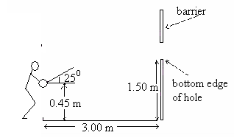
- A student attending a school fete is keen to win a prize in a throwing contest. To win a prize he must throw a ball underarm through a hole in a barrier and hit a target on the other side. He stands 3.00 m in front of the hole, the bottom edge of which is 1.50 m above the ground. If he releases the ball at an angle of 25.0⁰ to the horizontal from 0.450 m above the ground, at what speed must he throw the ball so it just enters the hole clearing the bottom edge? (5 marks)

